Projeto I

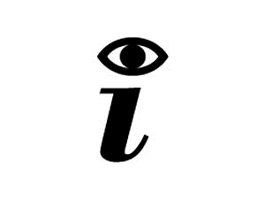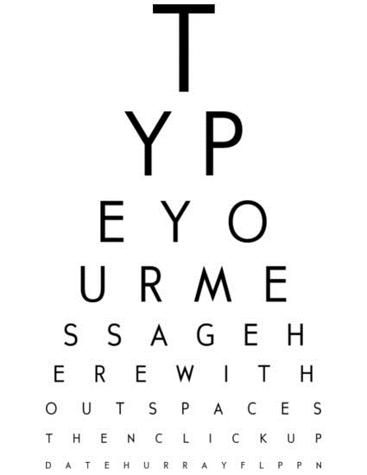 EST

**Grupo 6:**

Fábio Magalhães – A75030

Rui Carvalho – A76279

Index

Problem Statement 3

Market Study 3

Constraints 4

Technical Constraints 4

Functional Requirements 4

Non-Functional Requirements 4

Hardware Specifications 5

Software Specifications 5

System Overview 6

Events 6

Use Cases 7

State Chart 7

Sequence Diagram 8

System Stack 8

Gantt Chart 9

Problem Statement

In today society mankind is constantly using digital devices, that are affecting, negatively, vision health. It's been a concern for the past years to fight this era’s side-effect. To get yourself diagnosed, you must go to a doctor, which in public healthcare means a long wait and sometimes may be costly.

The Project’s goal is to design a tool to help diagnose irregularities in human vision, such as astigmatism, near-sightedness, and colour blindness. With only one device the user will be able to self-diagnose in an interactive and fast way.

We will have a screen showing images, that the user must identify. The device will recognise the answer and evaluate it. In the end of the test it will give you a result of how good or not your vision is.

Market Study

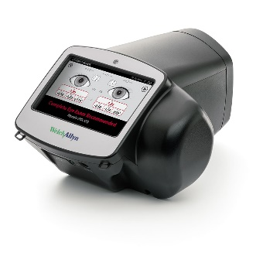There are already a lot of vision diagnostics devices. Although these devices are all equipment that should be handle by a professional technician, we found some that compare to our project.

***SPOT* Vision Screener:**

Professional, portable device. Unlike ours, the device diagnoses the patient through a camera, screening the eye directly. This equipment is extremely expensive.

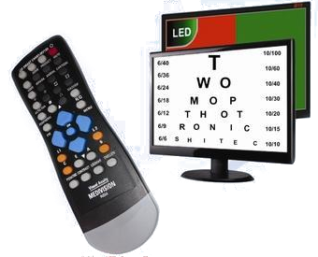***Medivision* Digital Acuity Chart:**

Similar to our project, it displays the test in a screen. Although the diagnostic must be made by a doctor/technician, as the device will not give any. The device, though cheaper than *SPOT*, is still very expensive.

Resuming there exists already good devices that perform the task, but they are very expensive and they all need an experienced technician to use them.

Constraints

* Budget must be minimal.
* Project developed by a team of two.
* Project must meet the final deadline.

Technical Constraints

* STM32F4-DISCOVERY board
* Keil uVision MDK-ARM
* Digital Signal Processor (DSP)
* FreeRTOS
* Minimum of three sensors

Functional Requirements

* Diagnose User
* Display the vision test on the TFT screen.
* Detect user interaction.
* Measure the distance between the device and the patient.
* Check suitability of the ambient light.
* Recognise speech input data.
* Show malfunctions on the display.
* Give audio signals.

Non-Functional Requirements

* Low Cost and low power.
* User-friendly interface.
* Small and portable.
* The system must have low latency.

Hardware Specifications

* STM32f4 Discovery Board
  + STM32F407VGT6 MCU
  + 32-bit ARM Cortex-M4 CPU with FPU core
  + 1-Mbyte Flash Memory
  + 192-Kbyte RAM
  + MP45DT02 ST MEMS Digital Microphone
  + CS43L22 Audio DAC
  + Up to 17 timers
  + 3 ADC 12-bit (up to 24 channels)
  + General-Purpose DMA
* Light sensor
  + LDR 1K-10K Ω
* Ultrasonic distance measurement
  + HC-SR04
  + 2-400 cm of non-contact measurement
* MEMS Digital Microphone onboard
* TFT w/ Touchscreen
  + ILI9488 Display Driver
  + 320x480 Resolution
  + Resistive Touchscreen

Software Specifications

* Keil uVison MDK-V5
* FreeRTOS
* C Language
* MatLab

System Overview

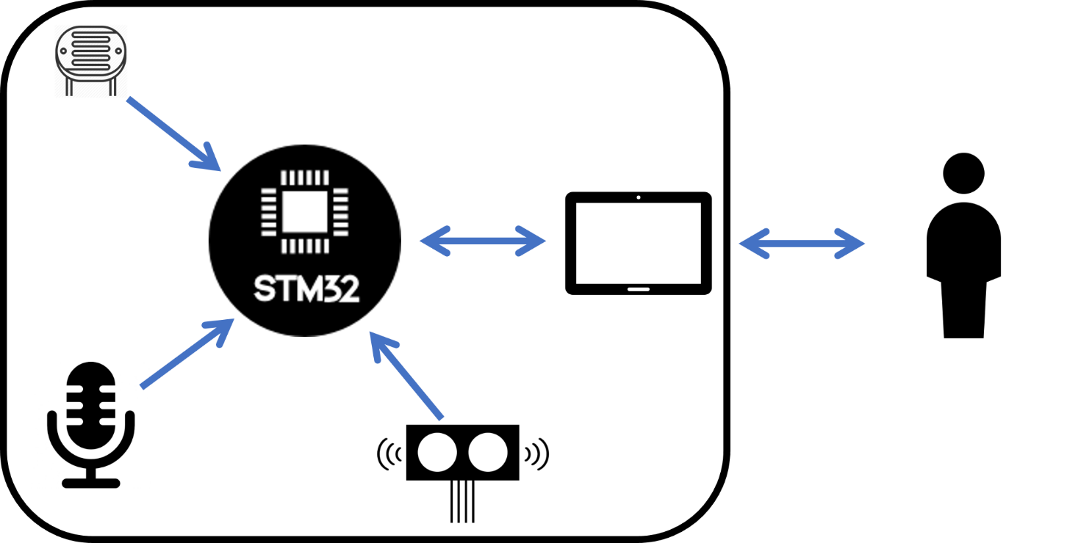

Events

|  |  |  |
| --- | --- | --- |
| Event | System Response | Source |
| On/Off | Turn System On/Off | User |
| Read Light | Reads ADC and processes data | Local Sys |
| Read Distance | Gets distance value | Local Sys |
| Display | Changes display data | Local Sys |
| Get voice | Gets and recognises voice input | User |

Use Cases

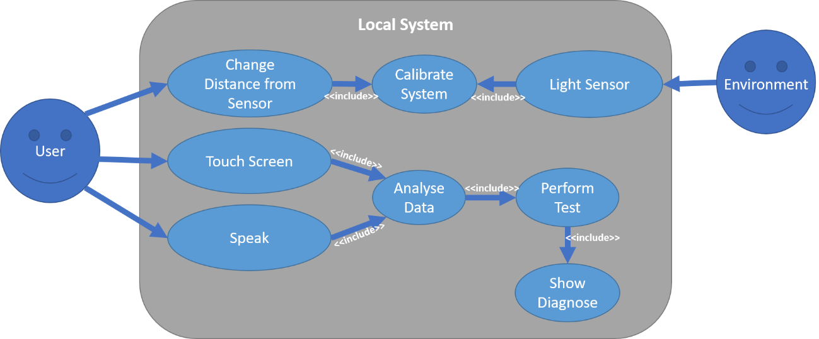

State Chart

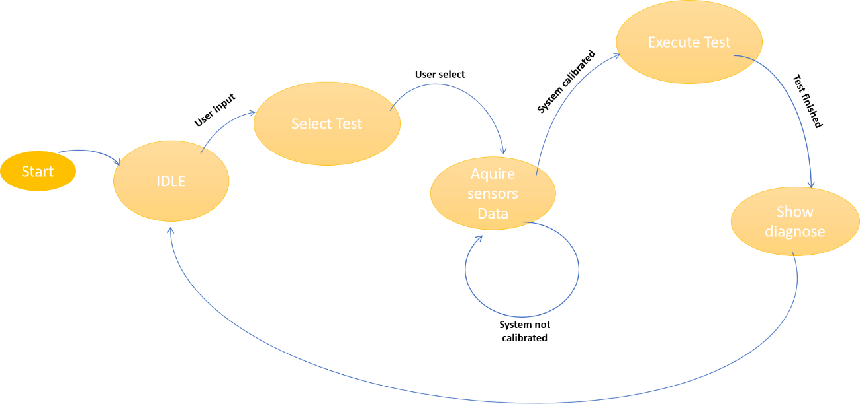

Sequence Diagram

|  |  |  |  |  |
| --- | --- | --- | --- | --- |
|  |  | Calibration | Test | Show Diagnose |
| User | Start Test | Change Distance | Perform Test |  |
| Ambient Light |  | Get Light Value |  |  |
| Touch Screen |  |  | Get Touch Position |  |
| Microphone |  |  | Get Speech Input |  |

System Stack

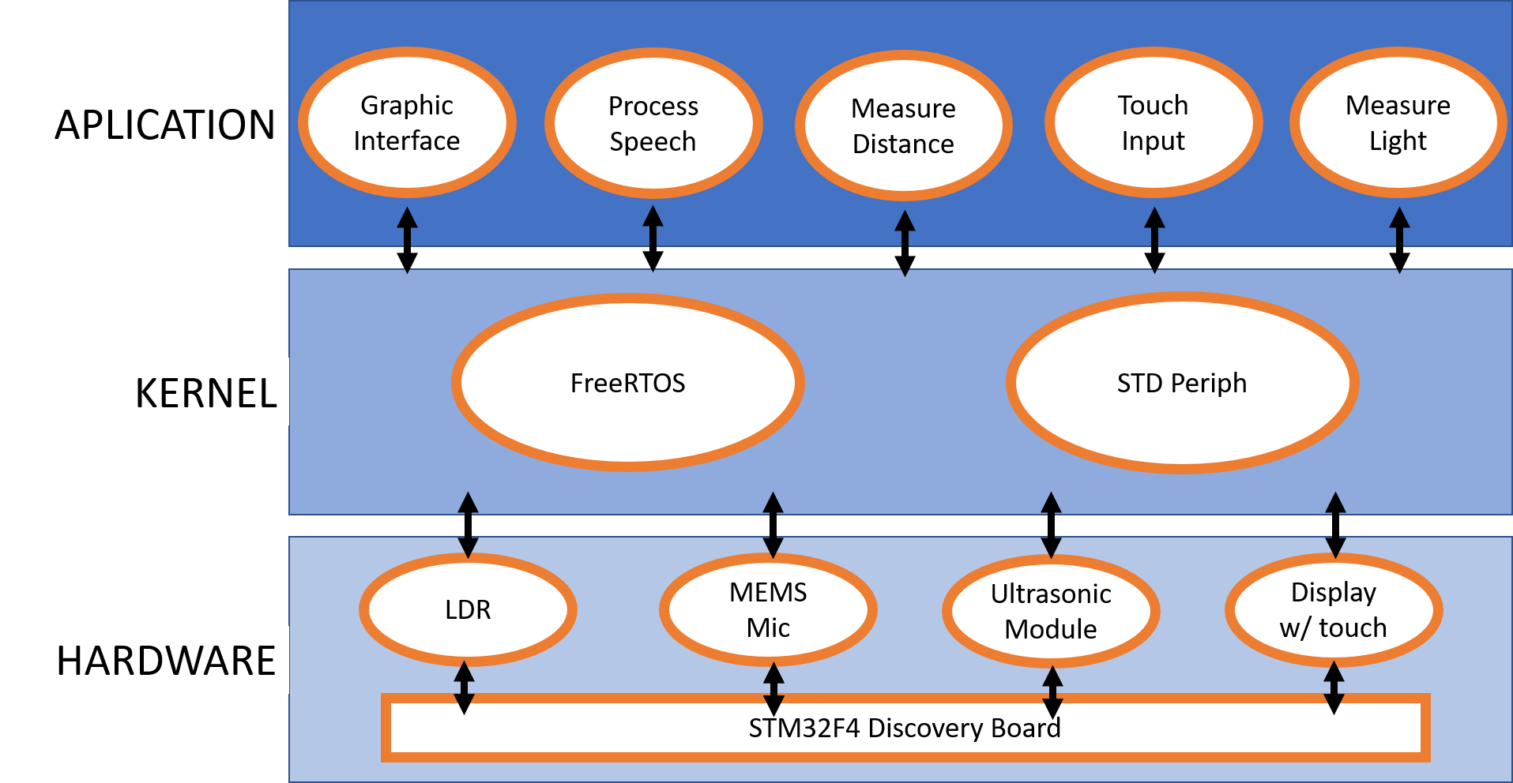

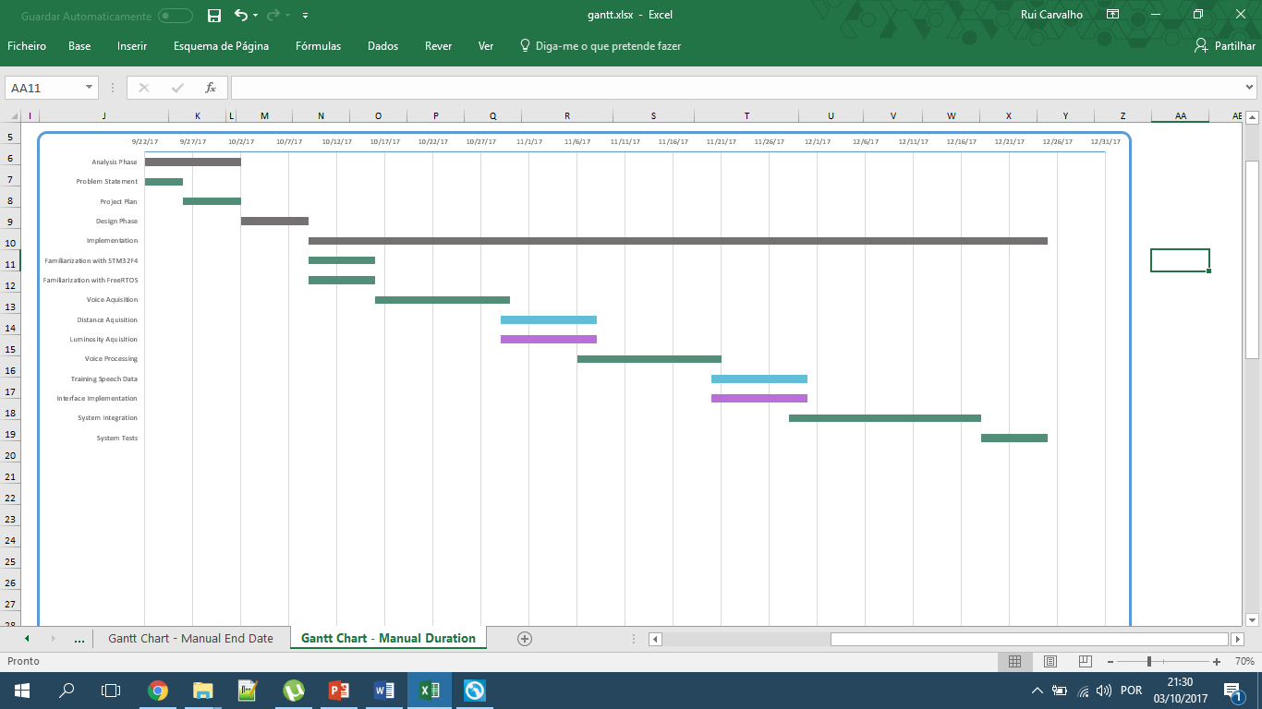Gantt Chart

